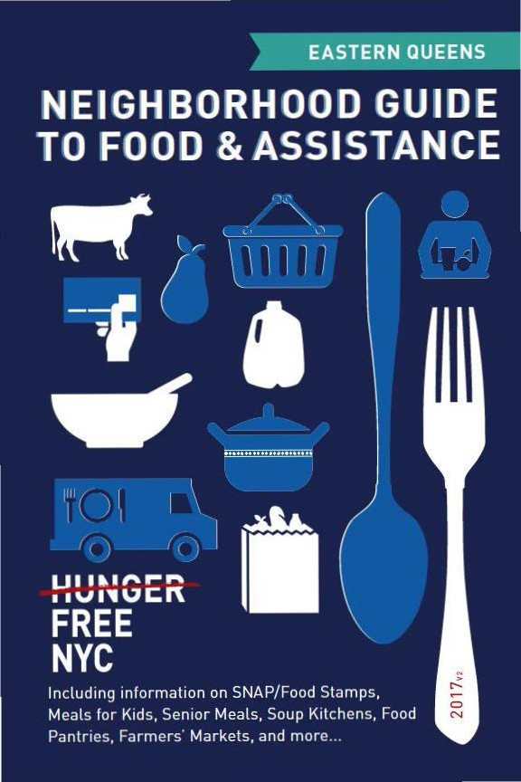

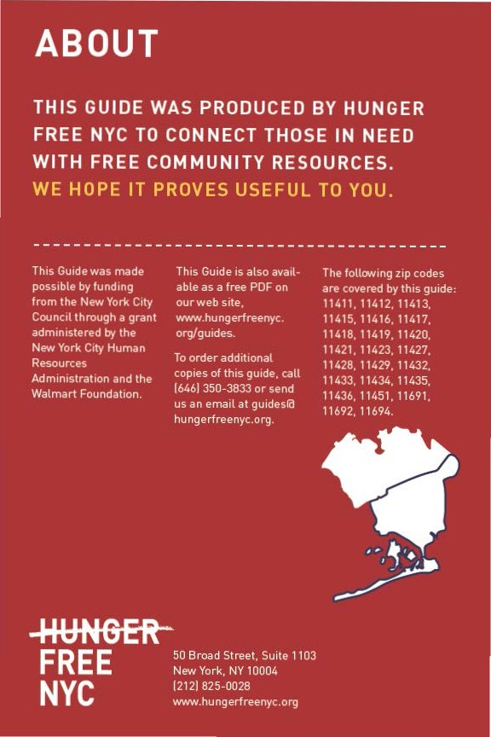

CON TEN TS

Food Stam ps/SNAP 4
6) Food fo r Kids 8
(I) Seni or Meals 11
0- Soup Kitchens & Food Pantries 12
e From the Fa rm 22
9 Em ployme nt & Tra in ing 23
Map of Locations 24
Other Assista nce 30
Emergency N um bers 31

Neighborhood Guide to Food and Assistance - Eastern Queens Edition
 SNAP/
FOOD STAMPS
SNAP benefits, the new name for food stamps, can help put healthy food on the table by providing monthly assistance
to purchase food at authorized grocery stores and farmers' markets. Benef its are provided monthly th rough a plastic benef it card, similar to a de bit or credit card.



EBT
Stands for Electronic Benefit Transfer. It's the system the goverment uses to disburse benefits.

SNAP
Stands for
Supplemental Nutrition Assistance Program. "SNAP benefits" is the same thing as ..food stamps."

WHAT SHOULD I KNOW?

ID Employment does not interfere with getting SNAP.Even if you a re working, but earning lowwages, you may be eligible.
ID Average SNAP benefits a re over $100 per person per month, and $250 or more
for families. That mea ns that SNAP benef its for the average family receiving them totals more than $3,000 worth of food support
each year.
ID Farmers' markets often accept SNAP benefits, so you ca n purchase fresh produce and food-producing seeds and plants using your benefits. For a complete list of farmers' markets that accept them , see page 22.

IINeighborhood Guide to Food and Assistance ·Eastern Queens Edition

AM I ELIGIBLE?


Eligibilit y is based on household size, income, expenses and other factors. Households have to meet income tests to receive benefits, but households that have members w ho are disabled or elderly (60 or older), or have out-of-pocket expenses for
.
child care or dependant ca re, ca n have higher incomes a nd still be eligible.

NUMBER OF PEOPLE
A
MONTHLY INCOME LIMIT
1
IN HOUSEHOLO | (PRE-TAXES] |  | SNAP BENEFITS
1 | $1 ,307 |  | $192
2 | $1 ,760 |  | $352
3 | $2,213 |  | $504
4 | $2,665 |  | $640

MAX.MONTHLY
2

Each additional household member
+$453
(approximately)
+ $144
(approximately)

11n effect
10/1/16 - 9/30/17.

21n effect
10/1/16 - 9/30/17.

If you meet the above income qualifications, it doesn't matter how much money you may or may not have in countable resources. In other words, you can save money for education , a home purchase, or retirement a nd still receive SNAP benefits.

Neighborhood Guide to Food and Assistance - Eastern Queens Edition II

IMMIGRANT ELIGIBILITY

Legal immigrants can often receive SNAP benefits if they:
- have lived in the country for 5 years or more; or
- are children (under age 18).
Ineligible immigrant parents can still receive benefits for their children even if a parent does not qualify.
Certain non-citizens, such as those admitted for humanitarian reasons, may also be able to receive benefits.
Immigration status is not negatively affected if you apply for or receive SNAP benefits.

HOW TO APPLY

Apply at Select Community Organizations
1

Call either of the below numbers to see if you may be eligible for benefits. If so, you’ll be offered an appointment at an agency in your community, where you’ll receive help in submitting your application electronically.
Hunger Free NYC
646 355 1475 & 646 350 1104

Neighborhood Guide to Food and Assistance - Eastern Queens Edition
6

ACCESSNYC
2
SNAP/FOOD STAMPS

Apply online at: www.nyc.gov/accessnyc

Visit Your Local HRA Office
3

Apply at a SNAP office near you:
- Jamaica snaP Center
165-08 88 Ave., 3rd Floor, 11432
718 722 8013
Mon-Fri 8:30am-6pm, sat 9am-5pm
- rockaway snaP Center
219 Beach 59 St., 1st Floor, 11692
718 722 8013
Mon-Fri 8:30am-5pm

You can also call 718 557 1399 to find a SNAP office near you and for information about qualifications, guidelines, and applications.

Neighborhood Guide to Food and Assistance - Eastern Queens Edition
7
I)FOOD FOR KIDS
WOMEN, INFANTS & CHILDREN
WIC is the Women, Infants & Children Program.
QUICK FACTS
ID WIC is for low-income pregnant women, breast-feeding women, and women with children under the age of five.
ID You can work and still get WIC.
ID You can continue to get cash assistance or SNAP benefits/food stamps while receiving WIC.
ID You can get WIC even if you are undocumented or not a citizen.

HOW TO APPLY
To find the WIC off ice nearest you call 800 522 5006, call 866 3-H UN G RY or v isit these local WIC off ices.

- Jamaica Hospital
134-20 Jamaica Ave, 11418
718 206 8600
Mon-Fri 7:30am-5:30pm, Wed open until 7pm, every other Sat 8am-3pm
- Queens Hospital Center - Queens General WIC 79-18 164th St., 11432
718 883 4868
Mon, Tue, Thu, Fri 8am-5pm (last appt. Spm); Wed 8am-7pm
- Public Health Solutions Jamaica WIC Center 90-40 160th St, 11432
718 526 4633
Mon 11am-6:30pm, Tue-Sat 8:30am-4pm

IINeighborhood Guide to Food and Assistance - Eastern Queens Edition
- Catholic Charities Jamaica WIC site
161-10 Jamaica Ave, 11432
FOOD FOR KIDS
718 657 2580
Mon 8am-7pm, tue-Fri 8am-4:30pm, sat once/month by appt. only
- Queens Hospital Center - south Jamaica WIC
114-02 Guy R. Brewer Blvd., 11434
718 883 6630
Mon, Wed-Fri 8am-5pm; tue 8am-7:30pm; every other sat
8:30am-3:30pm
- Joseph P. addabbo Community Health Center - Farmers Blvd.
114-39 Sutphin Blvd., 11434
718 945 7150
Mon, Wed-Fri 8am-5pm; tue 8am-6pm; sat 8:30am-2pm
- Jamaica Hospital - Medisys Hollis ave.
188-03 Jamaica Ave, 11423
718 479 0873
Wed 8:30am-5pm
- Joseph P. addabbo Community Health Center
1288 Central Ave., 11691
718 945 7150
Mon 8am-6pm, tue-Fri 8am-5pm, sat 8:30am-2pm, sun 12pm- 5pm
- Joseph P. addabbo Community Health Center - Beach Channel
6200 Beach Channel Dr., 11692
718 945 7150
Mon, tue, thu, Fri 8am-5pm; Wed 8am-6pm; sat 8:30am-2pm

Neighborhood Guide to Food and Assistance - Eastern Queens Edition
9
sCHOOL & suMMEr MEaLs

sFsP is the Summer Food Service Program, also known as Summer Meals.
QuICK FaCts
During school, free breakfasts are available to all children regardless of income, with no paperwork required.
Many public school students are also eligible for free or reduced price lunch. An application may be required.
Eligibility for school meals is not impacted by immigration status.
In June, July and August, lunch and breakfast are served for free to all children under 19 at many public schools, houses of worship, recreation centers, and community centers - no application or registration required.
Visit www.schoolfoodnyc.org for more information about school breakfast, school lunch, and summer meals. For nearby summer meals sites, text FOOD to 877-877, call 311, or call the National Hunger Hotline at 866 3-HUNGRY.

Neighborhood Guide to Food and Assistance - Eastern Queens Edition
10

eSENIOR MEALS
MEALS AT SENIOR CENTERS
Senior centers often serve meals for older people. Some centers offer free meals, oth ers ask for a small contribution !from fifty cents up to a few dollars!. This contribution may be voluntary or required. Senior cen ters and other sites with food for seniors are marked with • in the Soup Kitchens and Food Pantries section.
FIND YOUR LOCAL SENIOR CENTER
Call 311 and be prepared to provide your ZIP code to the operator.

MEALS- ON- WHEELS PROGRAM
If you are homebound and over the age of 60, you can receive home-delivered meals up to 7 days a week. Household income does not
affect eligibility.
HOW TO APPLY
To request meals-on-wheels service , call yourlocal case management agency.
To find the appropriate agency, contac t the Citymeals-on-Wheels' Program Department at 212 687 1234 or the National Hunger Hotline at 866 3-HUNGRY.
Neighborhood Guide to Food and Assistance - Eastern Queens Edition
OUP KITCHENS OFOOD PANTRIES
Agencies listed as sou p kitchens provide prepared meals during
their listed serving times, wh ile agencies listed as food pantries provide bags of food to be prepared at home.
Whilewe try to keep this list as accurate and up-to-date as possible, we recom mend calling the agency before going to confirm their schedule. Some agencies require a referral, I D, or proof of address. To conf irm, contact the agency directly, call the NYC Emergency Food Line at 866 888 8777 or call the National Hu nger Hotline at 866
3HUN GRY. Agencies ma rked with •are senior centers and/or provide food specifically for seniors.

KEW GARDENS, OZONE PARK,WOODHAVEN ,RICHMOND HILL
11414-11421
- All Nations Baptist Church of Woodhaven 86-74 80th St., 11421
718 847 4229
Food Pantry :Sat 1pm (Sept-May). 11a m (Jun-Aug) Sign up Sam -9am.
- St.Mary Gate of Heaven 101-18 104th St., 11416
718 847 6260
Food Pantry :Every other Thu 11am-1pm
ID with address required, serves residents of 11416 and 11417.
- Elohim Community Development and Outreach 87-47 111th Street, 11418
917418 7906
Food Pantry :Fri 9am-11 am
Bring I D and proof of address first time to reg ister.
II

Neighborhood Guide to Food and Assistance - Eastern Queens Edition
- richmond Hill sDa Community services
PANTRIES & KITCHENS
114-08 Jamaica Ave, 11418
718 301 3179
Food Pantry: sun 8am-9am
- the river Fund
89-11 Lefferts Blvd., 11418
718 441 1125
Food Pantry: sat 7am-11am
Benefits Enrollment and Recertification Mon-Fri 9am-2:30pm.
- saint Benedict Joseph Labre Church Food Pantry
94-40 118th St., 11419
718 849 4048
Food Pantry: 3rd thu 10am-11:30am Photo ID and proof of address required.
- Christina Home Care Food Pantry
120-13 Liberty Ave., 11419
917 592 8686
Food Pantry: Fri 2pm-5pm. Occasionally opens at 11am Services for employment training, job placement, home care available.
- st. theresa of avila Church Community services
109-26 130th Street, 11420
718 322 5547
Food Pantry: Mon, thu 9am-11am ID required.
- Leviticus Church of God in Christ
114-12 Van Wycke Expressway, 11420
718 322 1095
Food Pantry: Wed 1pm-2pm, sat 12pm-1pm
- Our Lady of Grace Parish Ministries
158-10 101st Street, 11414
718 845 6635
Food Pantry: tue, thu 10:30am-1pm ID required.

Neighborhood Guide to Food and Assistance - Eastern Queens Edition
13
JaMaICa
11432-11436
- Brooks Memorial united Methodist Church
143-22 109th Ave., 11435
718 658 8822
Food Pantry: thu 6pm-8pm; 1st, 3rd sat 10am-12pm Photo ID required.
- Blanche Memorial Church 109-74 Sutphin Blvd., 11435 718 298 8335
Food Pantry: tue 9am-9:45am ID required.
- Christ apostolic Church 108-02 Sutphin Blvd., 11435 718 658 8981
Food Pantry: sat 10am-12pm
Clothing pantry, food stamps screening, and counseling services available.
- aCQC (aIDs Center of Queens County), Jamaica
89-74 162nd St., 11432
718 896 2500
Food Pantry: tue, thu 8:30am-11am
Get there early to get a ticket, first come first served, only 75 people will be served. ID required.
- salvation army Jamaica Citadel
90-23 161st Street, 11432
718 297 4860
soup Kitchen: Mon-Wed 12pm-1pm
Food Pantry: thu 10am-11am
For food pantry, must register in person for food pantry with valid photo ID and proof of address. Must register ahead of time on Mon, Tue, or Wed 2pm.
- First reformed Church of Jamaica
159-29 90th Ave., 11432
718 658 6333
soup Kitchen: Mon 5pm-6pm

Neighborhood Guide to Food and Assistance - Eastern Queens Edition
14
- First Presbyterian Church in Jamaica
PANTRIES & KITCHENS
89-60 164th St., 11432
718 526 4775 x29
soup Kitchen: Wed 5:30pm-6:30pm
Food Pantry: tue 10am-12pm; 4th sat 9am-11am
Photo ID and proof of address required for pantry, clients can pick up once per month.
- Presentation of the Blessed Virgin Mary
88-19 Parsons Blvd., 11432
718 739 0241
soup Kitchen: thu 5:30pm-7pm
- Jamaica Hispanic sDa Church
88-28 161st St., 11432
718 736 5291
Food Pantry: sun 8am-9am Sign in required.
- First united Methodist Church of Jamaica
162-10 Highland Ave, 11432
718 739 2269
Food Pantry: Mon 8:30am-9:30am
Current ID and proof of address required. Closed on holidays
- st. nicholas of tolentine Church
150-75 Goethals Ave., 11432
718 969 3226
Food Pantry: Mon-Fri 9am-12pm, 1pm-4pm (referral required);
thu 9am-12pm (no referral required)
- tabernacle of Prayer
90-07 Merrick Blvd., between 90th & 91st, 11432 718 657 4210
Food Pantry: Fri 10am-11:15am ID required.
- river Fund Mobile unit - Queens
Rufus King Park, 150 St between 89 Ave. & Jamaica Ave., 11432
Food Pantry: 1st, 3rd tue 11am-12:30pm

Neighborhood Guide to Food and Assistance - Eastern Queens Edition
15
- Jamaica service Program for Older adults
92-47 165th St., 11433
718 657 6618
Food Pantry: Mon-Fri 8:30am-4:30pm
Serves seniors (60+) but will provide pantry bag first time for those under 60 and refer to other pantries.
- the Harding Ford Vision, Inc 157-22 South Road, 11433 347 661 7382
soup Kitchen: Wed 10am-12pm
Food Pantry: Wed 10am-12pm, sat 2pm-4pm Bring cart or bags.
- st. Bonaventure-st. Benedict the Moor Food Pantry
171-17 110th Avenue, 11433
718 526 0040
Food Pantry: 2nd, 4th tue 10am-12pm ID required.
- Bethany Baptist Church of Jamaica
157-11 111th Ave, 11433
718 659 1091
soup Kitchen: Wed 12pm-3pm
Food Pantry: tue 11am-1pm
- Calvary Baptist Church Food Pantry 111-10 Guy R. Brewer Blvd., 11433 718 523 8986
Food Pantry: Wed 10am-12pm, thu 11:30am-1:30pm ID required.
- Greater allen a.M.E. Cathedral of new York
110-31 Merrick Blvd., 11433
718 206 4600
soup Kitchen: Mon, thu 11am-1pm
Food Pantry: Mon, thu 11am-1pm
- st. Clement Pope roman Catholic Church
141-11 123rd Ave., 11436
718 529 0273
Food Pantry: 1st, 3rd thu 5pm-6pm

Neighborhood Guide to Food and Assistance - Eastern Queens Edition
16
- Morris Brown aME Church - Helping Hand
PANTRIES & KITCHENS
145-03 Rockaway Blvd., 11436
718 322 7596
soup Kitchen: sat 1pm-2pm Food Pantry: Wed 10am-12pm ID preferred for pantry.
- union united Methodist Church
126-22 150th Street, 11436
718 529 3691
soup Kitchen: tue 6:30pm-7:30pm
Food Pantry: Fri 4pm-5:30pm Call for emergency food.
- Holy Ghost upper room Filling station Ministry
146-17 133rd Ave., 11436
718 529 2060
Food Pantry: sat 10am-11am
ID and proof of address needed for all household members.
- national sorority Phi Delta Kappa "Big sister"/Phi Delta Kappa ruby s. Couche Big sister Center
117-08 Merrick Blvd., 11434
718 723 1119
Food Pantry: tue, thu 4pm-6pm
- Christ Church International 122-20 Merrill St., 11434 516 860 4432
Food Pantry: 2nd, 3rd, 4th sat 10am-12pm ID required.
- Project Hope Charities Inc. 170-20 140th Ave., 11434 718 529 0005
Food Pantry: sat 11am-1pm
- Church of Christ the King Pantry
145-39 Farmers Blvd., 11434
718 528 6010
Food Pantry: tue 2pm-3pm ID preferred.

Neighborhood Guide to Food and Assistance - Eastern Queens Edition
17
st. aLBans, sPrInGFIELD GarDEns, QuEEns VILLaGE, CaMBrIa HEIGHts, HOLLIs
11423, 11427-11429, 11411-11413
- Walk in Love Family Center
202-11 Jamaica Avenue, 11423
Food Pantry: Wed 1pm-3:30pm, thu 5pm-6:30pm, sun 1pm- 3pm. Distribution is while supplies last.
- Catholic Charities Church of the Incarnation/Incarnation Parish Pantry
89-28 207th Street, 11427
718 726 9790
Food Pantry: Fri 1pm-3pm ID required.
- International shining stars Family Inc.
220-20 94th Drive, 11428
646 4097146
Food Pantry: sat 11am-3pm
- Hollis avenue Congregational Church
211-04 Hollis Ave., 11429
718 468 1498
Food Pantry: tue 11:30am-1pm
ID preferred, serves residents of Hollis Ave/Cambria Heights.
- Genesis transitional Housing Ministries Inc.
195-12 Hollis Ave, 11412
718 217 6530
Food Pantry: 2nd, 4th Fri 9am-1pm
- second Chance Deliverance Church
200-12 Hollis Avenue, 11412
917 767 6262
Food Pantry: tue 11am-2pm
- Grace united Methodist Church
200-08 Murdock Ave, 11412
718 465 5621
Food Pantry: sat 1pm-finished

Neighborhood Guide to Food and Assistance - Eastern Queens Edition
18
- First Church of God in Christ 187-10 Baisley Blvd., 11412 718 712 4831
PANTRIES & KITCHENS
soup Kitchen: Wed 12pm-1:30pm
Food Pantry: thu 1:30pm-3pm
Photo ID required for pantry, tickets handed out at 12pm.
- Our Lady of Light Food Pantry
118-22 Riverton St., 11412
718 528 1220
Food Pantry: every other Wed 12:30pm-1:30pm
- st. albans Baptist Church 196-20 119 Ave., 11412 718 723 8005
Food Pantry: 1st, 3rd sat 10am-12pm
- Queens tabernacle Church 114-03 Colfax St., 11411 718 465 4448
Food Pantry: tue 3pm, sat 11am (often starts earlier in the winter)
- Kerith sDa Church
230-11 Linden Blvd., 11411
917 523 7476
Food Pantry: Wed 5:30pm-7:30pm
- Queens Faith temple Outreach Center
217-03 Merrick Blvd., 11413
917 603 9295
Food Pantry: sun 2pm-4pm
- st. Luke Baptist Church Food Pantry
133-28 232nd St., 11413
718 276 7066
Food Pantry: Mon-Wed 9am-3pm; periodically open Thu, Fri - call/visit to confirm.
- First Presbyterian Church of springfield Gardens
216-02 137th Ave., ramp to basement, 11413 718 528 7744
Food Pantry: Wed 11am-12pm ID required.

Neighborhood Guide to Food and Assistance - Eastern Queens Edition
19
- Gethsemane soul saving Outreach
145-41 228th Street, 11413
917 519 6051
Food Pantry: Wed 1pm-2pm
tHE rOCKaWaYs
11691-11693
- st. Camillus rC Church
99-15 Rockaway Beach Blvd., 11694
718 634 8229
Food Pantry: Wed 10am-2pm
ID required. Serves residents from Beach 95th St and above
- Beach Church
224 Beach 97th St., 11693
718 634 2424
Food Pantry: sat 10am-2pm
- Catholic Charities BFFY - st. Vincent de Paul at st. rose of Lima
130 Beach 84th Street, 11693
718 634 7394
Food Pantry: tue, Fri 10am-12pm
Must live between Beach 54th to Beach 94th St. Photo ID and proof of address required first visit. Can visit once/month.
- the action Center Food Pantry
57-10 Beach Channel Drive, 11692
718 869 0031
Food Pantry: every other Wed 11:30am-12:30pm, sat 10am- 1:30pm
ID required for registration.
- Full Gospel tabernacle Food Pantry
361 Beach 42nd St., 11691
718 327 2221
Food Pantry: 3rd sat 10am-12pm Photo ID required.
- J.u.s.t.I.C.E. Organization/Jesus is Justice Mission Inc.
219 Beach 28 St., 11691
718 772 7951
Food Pantry: Wed 12pm-2pm

Neighborhood Guide to Food and Assistance - Eastern Queens Edition
20
- st. Mary star of the sea
PANTRIES & KITCHENS
1920 New Haven Avenue, 11691
718 327 1133
Food Pantry: tue or Fri 1pm-2:30pm
Call to confirm day. Photo ID and proof of address required. 1st, 3rd week for non-seniors; 2nd, 4th week for seniors; 5th week open to all.
- aCQC (aIDs Center of Queens County), Far rockaway
1139 Foam Place, 11691
718 868 8645
Food Pantry: Wed, Fri 1pm-3pm
Can come once/month. Photo ID required.
- Jewish Community Council of the rockaway Peninsula
1525 Central Avenue, 11691
718 327 7755
Food Pantry: tue, thu 9:30am-1:30pm
ID required, can come once/month, serves residents of the Rockaways.
- First Church of God
21-23 Birdsall Ave., 11691
718 327 1114
Food Pantry: 2nd, 4th Sat 1pm-3pm.
- First Baptist Church/H.O. scott Education and Community Center
15-10 Redfern Avenue, 11691
718 327 2208
Food Pantry: Mon, Wed 12pm-2pm
- First Presbyterian russell sage Memorial Food Pantry
896 Central Avenue, 11691
718 909 5953
Food Pantry: sat 9am-10:30am Must be 18 yrs or older.

Neighborhood Guide to Food and Assistance - Eastern Queens Edition
21
eFROM THE FAR M
New Yorkers can access foods straight from the farm in two ways: farmers' markets and community su pported ag riculture programs or CSAs.

FARMERS' MAR KETS
All farmers' markets listed accept EBT/SNAP (food stamps).

- Jamaica Friday Down to Earth Farmers' Market Parsons Blvd. between Archer and Jamaica Ave., 11432 Fri 8:30am-4pm, Jun-Nov
- Jamaica Saturday Down to Earth Farmers' Market
160th St. & Jamaica Ave., 11432
Sat 8:30am-4pm, Ju n-Nov
- Edgemere Farm Market
Beach Channel Dr. and Beach 45 St., 11691
Sat, Sun 9am-2pm, May-Oct

CSA PR OGR AMS

CSA members purchase "shares" in an entire season of high quality, fresh produce grown by local farmers. Members usually pay for their shares in advance, but some CSAs adjust payment to income, ac cept SNAP benefits, and allow some members to pay week to week. Members typically pick up boxes of produce from a set location every week though some CSAs have half-shares available for pick up every other week.
Note that sign up is generally March to May, with the first picku p in June or July a nd the last one in late October or early November. As a rule, late sign up is not permitted. Some CSAs also have limited winter shares.
IINeighborhood Guide to Food and Assistance - Eastern Queens Edition

Corbin Hill
Multiple pickup locations. Allows signups Tuesday/Wednesday before first pickup. Permits weekly payment a nd payment via SNAP.Weekly in summer, every other week in winter. Reduced price shares available. Visit Corbin Hill's website, call, or email to find a CSA prog ra m near you and sign up.
Contact: infolacorbinhillfarm.com, 646 254 2250
Web: www.corbinhillfoodproject.org/new-farm-share/

Just Food
Multiple pickup locations.Sign up deadlines and SNAP accepta nee
va ry. Winter shares available from some CSAs. Visit Just Food's web site, call, or email to find a CSA program near you. Contact the CSA directly to sign u p.
Contact: infolajustfood .org, 212 645 9880
Web: www.justfood. org/csaloc

A JOB TRAINING &
RESOURCES
Certain individuals may be required to be employed. seeking employment and I or enrolled in a training program in order to receive SNAP benefits.

EMPLOYMENT & TRAINING

Visit the following sites to find out more about tra ining and education prog ra ms across the city:
www1 .nyc.gov/htmVsbs/wfl/htmVdevelop/deve lop.shtml www1 .nyc.gov/site/hra/help/types-training-education .page
Neighborhood Guide to Food and Assistance - Eastern Queens Edition II
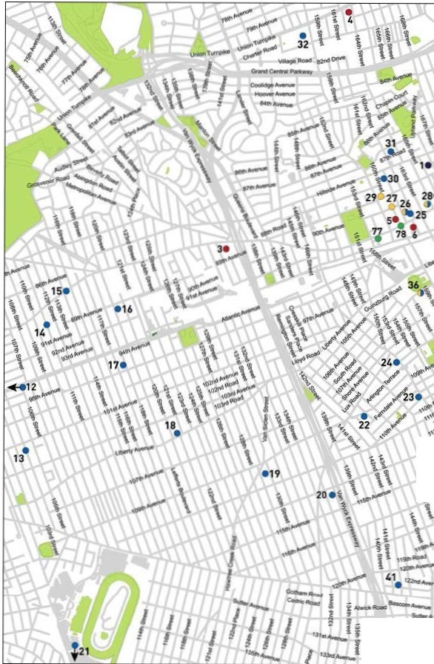

\
'
\

-- fl
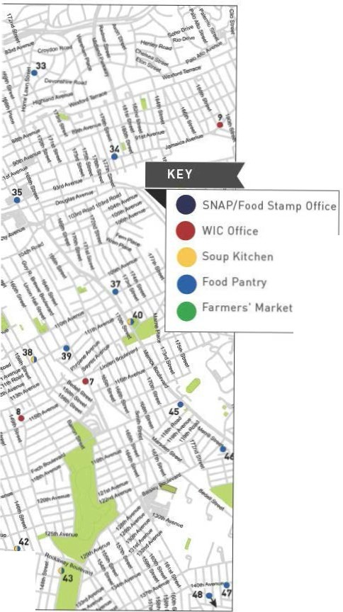


j 44 II
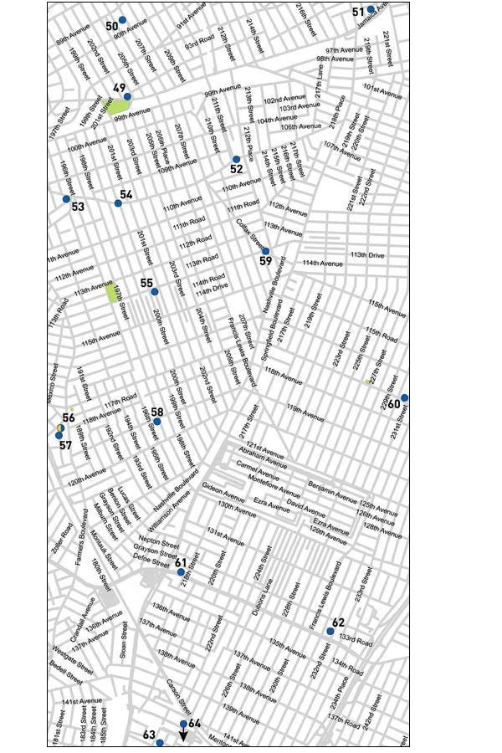
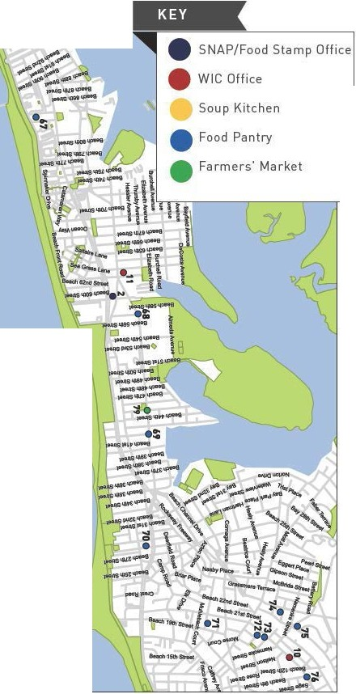
•z; . _....
..
..


Z --+
II
Feel free to use t his space for your own notes.

IINe ighborhood Guide to Food and Assistance - Eastern Queens Edition


Neighborhood Guide to Food and Assistance - Eastern Queens Edition II
OTHER ASSISTANCE
Additional organizations in your neighborhood that can as- sist you with matters other than food support.

MEDICAL CARE

Queens Hospital Center
82-68 164 St., 11432
718 883 3000
Jamaica Hospital
8900 Van Wyck Expressway, 11418
718 206 6000
south Queens Health Center
114-02 Guy R. Brewer Blvd., 11434
718 883 6699
Charles B. Wang Community Health Center
136-26 37 Ave., 11354
718 886 1200
Queens Health network Medical Center at Parsons
90-37 Parsons Blvd., 11413
718 334 6440
Joseph P. addabbo Family Health Center
6200 Beach Channell Dr., 11692
718 945 7150

HEALTH INSURANCE

Affinity Health System
Information regarding health insurance, including enrollment in Medicaid, Medicare and other plans.
General Info 866 694 9809
168-22 Jamaica Ave., Jamaica 11432

Neighborhood Guide to Food and Assistance - Eastern Queens Edition
30

Provides specific and detailed assistance regarding a wide range of legal topics, including agencies that might be able to help you find an attorney to represent you in court.
LEGAL ASSISTANCE
The City Bar Justice Hotline
212 626 7383
Mon–Thu 9am-5pm, Fri 9am-1pm
Free, basic legal advice on a range of civil issues. Will not provide an attorney or assist with in-court representation.
X
MORE HELP
EMERGENCY NUMBERS

National Hunger Hotline 866 3-HUNGRY (866 348 6479)
NYC Hunger Hotline 866 888 8777 Police, Fire or Ambulance: 911 Emergency Shelter: 311
Homeless Hotline: 800 994 6494, 212 533 5151
Immigration Hotline: 212 419 3737, 800 566 7636
Center for Disease Control: 800 232 4636
Poison Control: 800 222 1222
AIDS Hotline: 800 541 AIDS, 800 233 7432 (Spanish)
Alcoholics Anonymous: 212 647 1680
Narcotics Anonymous: 212 929 6262
Gamblers Anonymous Hotline: 855 222 5542
Domestic Violence Hotline: 800 621 4673
Battered Women Hotline: 718 499 2151
Rape & Sexual Assault Hotline: 212 423 2140, 212 227 3000
Child Abuse Hotline: 800 342 3720
Runaway Hotline: 800 786 2929 (800 RUN AWAY)
Crime Victim Hotline: 212 577 7777, 800 689 4357
Suicide Hotline: 800 273 8255
National Crisis Line: 800 999 9999

Credits: Icons adapted from The Noun Project collection. Map data © OpenStreet- Map contributors.

Neighborhood Guide to Food and Assistance - Eastern Queens Edition
31
WHAT AM I ELIG IBLE FOR ?

Use the chart below to see what programs may be available for you and your family.
e CD 0


PEOPLE WITH CHILDREN
e 0

PEOPLE WITHOUT CHILDREN
e a> 0

SENIOR CITIZENS
e CD 0

HOMELESS INDIVIDUALS

LEGAL IMMIGRANTS
e CD 0

UNDOCUMENTED IMMIGRANTS
() 0

A SNAP/ Food Stamp 0Groceries at Food Pantries WIC Packages
'1Benefits
School Breakfast & Lunch - Meals at Soup Kitchens
W Free Summer Meals for Children
/IP\ Meals at Senior Centers
\ii Home-delivered Meals
-IU:JN6ER

FREE
NYC
Have any suggestions on how to make this Guide better? Email gu ideslilhu ngerf reenyc.org.

